 | 26.10.21 Editors - Properties Editor - Particle Properties Tab - Hair - Physics panel
Table of content
Detailed table of content 1
Physics Panel 5
Physics Type 5
Physics Panel - Physics type None 5
Physics Panel - Physics type Newtonian 5
Mass 5
Multiply Mass with Size 5
Forces subpanel 5
Deflection subpanel 6
Integration subpanel 6
Physics Panel - Physics type Keyed 7
Mass 7
Multiply Mass with Size 7
Loops 7
Use Timing 7
Relations sub tab 8
Physics Panel - Physics type Boid 9
Mass 9
Multiply Mass with Size 9
Movement subpanel 9
Physics Panel - Physics type Fluid 16
Mass 16
Multiply Mass with Size 16
SPH Solver 16
Stiffness 16
Viscosity 17
Buoyancy 17
Forces subpanel 17
Deflection subpanel 17
Integration subpanel 17
Springs Subpanel 18
Fluid Interaction 19

Detailed table of content
Detailed table of content
Detailed table of content 1
Physics Panel 5
Physics Type 5
Physics Panel - Physics type None 5
Physics Panel - Physics type Newtonian 5
Mass 5
Multiply Mass with Size 5
Forces subpanel 5
Brownian 5
Drag 6
Damp 6
Deflection subpanel 6
Size Deflect 6
Die on Hit 6
Collision Collection 6
Integration subpanel 6
Integration 6
Euler 6
Verlet 6
Midpoint 6
RK4 7
Time step 7
Sub frames 7
Physics Panel - Physics type Keyed 7
Mass 7
Multiply Mass with Size 7
Loops 7
Use Timing 7
Relations sub tab 8
Particle Targets list 8
Drag Handler 8
Search Field 8
Invert 8
Sort by Name 8
New Particle Target 8
Move Up Target / Move Down Target 8
Target Object 8
System 8
Time 8
Duration 8
Physics Panel - Physics type Boid 9
Mass 9
Multiply Mass with Size 9
Movement subpanel 9
Allow Flight 9
Allow Land 9
Allow Climbing 9
Max Air Speed 9
Min Air Speed 10
Max Air Acceleration 10
Max Air Angular Velocity 10
Air Personal Space 10
Landing Smoothness 10
Max Land Speed 10
Jump Speed 10
Max Land Acceleration 10
Max Land Angular Velocity 10
Land Personal Space 10
Land Stick Force 10
Collision Collection 10
Battle subpanel 11
Health 11
Strength 11
Aggression 11
Accuracy 11
Range 11
Misc subpanel 11
Banking 11
Pitch 11
Height 11
Relations subpanel 11
Deflection 11
Force Fields 11
Particle Targets list 12
Drag Handler 12
Search Field 12
Invert 12
Sort by Name 12
New Particle Target 12
Move Up Target / Move Down Target 12
Target Object 12
System 12
Mode 12
Enemy 12
Friend 12
Neutral 13
Boid Brain subpanel 13
List of Rules 13
Search Field 13
Invert 13
Sort by Name 13
Add Boid Rule 13
All rules 13
Rule Evaluation 13
Average 13
Random 14
Fuzzy 14
Rule Fuzziness 14
In Air 14
On Land 14
Goal Boid Rule 14
Object 14
Predict 14
Avoid Boid Rule 14
Object 14
Predict 14
Fear Factor 14
Avoid Collision Boid Rule 15
Boids 15
Deflectors 15
Look Ahead 15
Separate Boid Rule 15
Flock Boid Rule 15
Follow Leader Boid Rule 15
Object 15
Distance 15
Line 15
Queue Size 15
Average Speed Boid Rule 15
Speed 15
Wander 15
Level 15
Fight Boid Rule 16
Fight Distance 16
Flee Distance 16
Remove Boid Rule 16
Move Up / Move Down Boid Rule 16
Physics Panel - Physics type Fluid 16
Mass 16
Multiply Mass with Size 16
SPH Solver 16
Double density 16
Classic 16
Stiffness 16
Viscosity 17
Buoyancy 17
Forces subpanel 17
Brownian 17
Drag 17
Damp 17
Deflection subpanel 17
Size Deflect 17
Die on Hit 17
Collision Collection 17
Integration subpanel 17
Integration 17
Euler 17
Verlet 18
Midpoint 18
RK4 18
Time step 18
Sub frames 18
Springs Subpanel 18
Force 18
Viscoelastic Springs 18
Elastic Limit 18
Plasticity 18
Initial Rest Length 18
Frames 19
Advanced 19
Rest Length 19
Factor Rest Length 19
Fluid Interaction 19
Particle Targets list 19
Search Field 19
Invert 19
Sort by Name 19
Target Object 19
System 19

Physics Panel

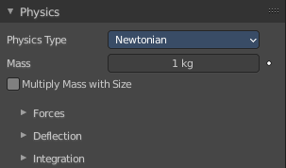
The movement of particles can be controlled and influenced in various ways. Physics is one of it.

Physics Type
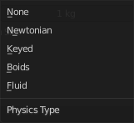
The kind of physics to influence the particles.

Physics Panel - Physics type None


The particles are created, and remains at their creation point.
This physics type does not have further settings.

Physics Panel - Physics type Newtonian
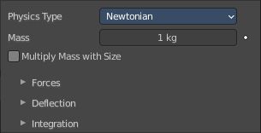
Particles are influenced by gravity.

Mass
Specify the mass of the particles.

Multiply Mass with Size
Causes larger particles to have larger masses.

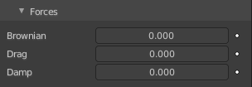
Forces subpanel

Brownian
Specify the amount of Brownian motion. Brownian motion adds random motion to the particles based on a Brownian noise field.

Drag
A force that reduces particle velocity in relation to its speed and size (useful in order to simulate air drag or water drag).

Damp
Reduces particle velocity (deceleration, friction, dampening).

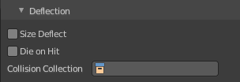
Deflection subpanel

Size Deflect
Use the particle size in deflections.

Die on Hit
Kill particle when it hits a deflector object.

Collision Collection
If set, particles collide with objects from the collection.

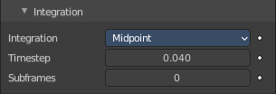
Integration subpanel
Integrators are a set of mathematical methods available to calculate the movement of particles. The following guidelines will help to choose a proper integrator, according to the behavior aimed at by the animator.

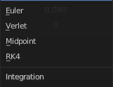
Integration

Euler
Also known as “Forward Euler”. Simplest integrator. Very fast but also with less exact results. If no dampening is used, particles get more and more energy over time. For example, bouncing particles will bounce higher and higher each time. Should not be confused with “Backward Euler” (not implemented) which has the opposite feature, the energy decrease over time, even with no dampening. Use this integrator for short simulations or simulations with a lot of dampening where speedy calculations are more important than accuracy.

Verlet
Very fast and stable integrator, energy is conserved over time with very little numerical dissipation.

Midpoint
Also known as “2nd order Runge-Kutta”. Slower than Euler but much more stable. If the acceleration is constant (no drag for example), it is energy conservative. It should be noted that in example of the bouncing particles, the particles might bounce higher than they started once in a while, but this is not a trend. This integrator is a generally good integrator for use in most cases.

RK4
Short for “4th order Runge-Kutta”. Similar to Midpoint but slower and in most cases more accurate. It is energy conservative even if the acceleration is not constant. Only needed in complex simulations where Midpoint is found not to be accurate enough.

Time step
The amount of simulation time (in seconds) that passes during each frame.

Sub frames
The number of simulation steps per frame. Sub frames to simulate for improved stability and finer granularity in simulations. Use higher values for faster-moving particles.

Physics Panel - Physics type Keyed
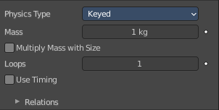
The path of Keyed particles is determined between particles of any two (or more) particle systems. This allows the creation of a chains of systems to create long strands or groovy moving particles. Basically the particles have no dynamics but are interpolated from one system to the next each frame.
To setup Keyed particles you need at least two particle systems in the Keys list.

Mass
Specify the mass of the particles.

Multiply Mass with Size
Causes larger particles to have larger masses.

Loops
Sets the number of times the entire Keys list is repeated. Disabled if Use Timing is enabled.

Use Timing
Specify the timing for each key independently, using the Time and Duration options. By default, the Use Timing option is deactivated, and the particles will pass through all keys for a time equal to its lifetime. A shorter lifetime means faster movement. The lifetime will be split equally between the keys, this may lead to varying particle speeds between the targets.

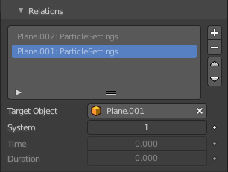
Relations sub tab

Particle Targets list
A list of the available particle systems. You need at least two.

Drag Handler
The two vertical lines at the end is a handler with which you can expand the list.

Search Field

You can expand a search field at the bottom of the list. Type in your term and hit enter to filter for your term.

Invert
Exclude the search term instead of searching for it.

Sort by Name
Sort the List by name.

New Particle Target
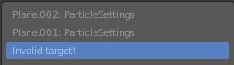
Add a particle target. You need to specify the object that contains the particle system, which can be done below. Empty particle targets are marked as Invalid target!

Move Up Target / Move Down Target
Move the selected particle target up or down in the list.

Target Object
Choose the target object that contains the particle system.

System
The index of the particle system on the target object.

Time
Becomes active when Use Timing is activated. The start time.

Duration
Becomes active when Use Timing is activated. The duration.

Physics Panel - Physics type Boid

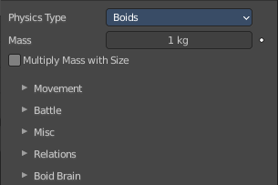
Boids particle systems are controlled by a limited artificial intelligence, which can be programmed to follow basic rules and behaviors. They are ideal for simulating flocks, swarms, herds and schools of various kind of animals, insects and fishes or predators vs. preys simulations. They can react on the presence of other objects and on the members of their own system. Boids can handle only a certain amount of information, therefore the sequence of the Boid Brain rules is very important. In certain situations only the first three parameter are evaluated.

Mass
Specify the mass of the particles.

Multiply Mass with Size
Causes larger particles to have larger masses.

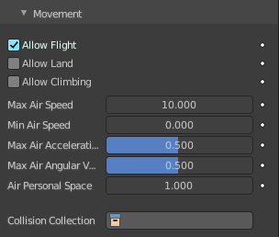
Movement subpanel
Boids try to avoid objects with activated Collision. They try to reach goal objects, and fly from “predators” according to the Boid Brain settings.
Boids can have different physics depending on whether they are in the air, or on land (on collision object).

Allow Flight
Allow boids to move in the air.

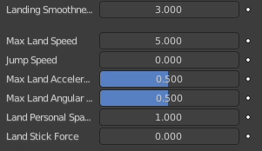
Allow Land
Allow boids to move on land. Activating this setting will reveal further sliders.

Allow Climbing
Allow boids to climb goal objects.

Max Air Speed
Set the Maximum velocity in the air.

Min Air Speed
Set the Minimum velocity in the air.

Max Air Acceleration
Lateral acceleration in air, percentage of the max velocity (turn). Defines how fast a boid is able to change direction.

Max Air Angular Velocity
Tangential acceleration in air, percent 180 degrees. Defines how much the boid can suddenly accelerate in order to fulfill a rule.

Air Personal Space
Radius of boids personal space in air. Percentage of particle size.

Landing Smoothness
How smoothly the boids land.

Max Land Speed
Set the Maximum velocity on land.

Jump Speed
Maximum speed for jumping.

Max Land Acceleration
Lateral acceleration on land, percent of max velocity (turn). Defines how fast a boid is able to change direction.

Max Land Angular Velocity
Tangential acceleration on land, percent 180 degrees. Defines how much the boid can suddenly accelerate in order to fulfill a rule.

Land Personal Space
Radius of boids personal space on land. Percentage of particle size.

Land Stick Force
How strong a force must be to start effecting a boid on land.

Collision Collection
Only collide with objects in this collection.

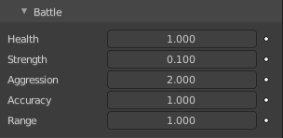
Battle subpanel

Health
Initial boid health when born.

Strength
Maximum caused damage per second on attack.

Aggression
Boid will fight this time stronger than enemy.

Accuracy
Accuracy of attack.

Range
Maximum distance of which a boid can attack.

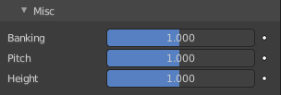
Misc subpanel

Banking
Amount of rotation around velocity vector on turns. Banking of 1.0 gives a natural banking effect.

Pitch
Amount of rotation around side vector.

Height
Boid height relative to particle size.

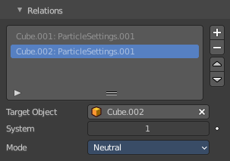
Relations subpanel
Boid particles can react with other particle systems. This list allows you to select other objects with their particle systems.

Deflection
Boids will try to avoid deflector objects according to the Collision rule’s weight. It works best for convex surfaces (some work needed for concave surfaces).

Force Fields
As other physics types, Boids is also influenced by external force fields.
In addition, special Boid force fields can be used with the Boids physics. These effectors could be predators (positive Strength) that boids try to avoid, or targets (negative Strength) that boids try to reach according to the (respectively) Avoid and Goal rules of the Boid Brain.

Particle Targets list
A list of the available particle systems.

Drag Handler
The two vertical lines at the end is a handler with which you can expand the list.

Search Field
You can expand a search field at the bottom of the list. Type in your term and hit enter to filter for your term.

Invert
Exclude the search term instead of searching for it.

Sort by Name
Sort the List by name.

New Particle Target
Add a particle target. You need to specify the object that contains the particle system, which can be done below. Empty particle targets are marked as Invalid target!

Move Up Target / Move Down Target
Move the selected particle target up or down in the list.

Target Object
Choose the target object that contains the particle system.

System
Index of the Object’s particle system as set in the list view in the particle panel.

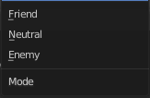
Mode

Enemy
Setting the type to Enemy will cause the systems to fight with each other.

Friend
Will make the systems work together.

Neutral
Will not cause them to align or fight with each other.

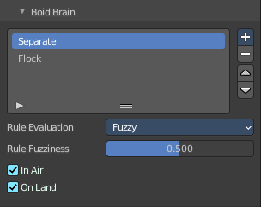
Boid Brain subpanel
The Boid Brain panel controls how the boids particles will react with each other. The boids’ behavior is controlled by a list of rules. Only a certain amount of information in the list can be evaluated. If the memory capacity is exceeded, the remaining rules are ignored.
The rules are by default parsed from top-list to bottom-list (thus giving explicit priorities), and the order can be modified using the little arrows buttons on the right side.

List of Rules
The list of the current rules.

Search Field
You can expand a search field at the bottom of the list. Type in your term and hit enter to filter for your term.

Invert
Exclude the search term instead of searching for it.

Sort by Name
Sort the List by name.

Add Boid Rule
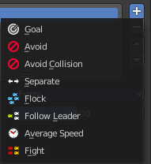
A list of the available boid rules. Each rule has different settings.

All rules

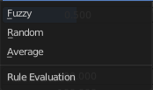
Rule Evaluation
There are three ways to control how rules are evaluated:

Average
All rules are averaged.

Random
A random rule is selected for each boid.

Fuzzy
Uses fuzzy logic to evaluate rules. Rules are gone through top to bottom. Only the first rule that affect above the Rule Fuzziness threshold is evaluated. The value should be considered how hard the boid will try to respect a given rule (a value of 1 means the Boid will always stick to it, a value of 0 means it will never). If the boid meets more than one conflicting condition at the same time, it will try to fulfill all the rules according to the respective weight of each.
Note! A given boid will try as much as it can to comply to each of the rules it is given, but it is more than likely that some rule will take precedence on other in some cases. For example, in order to avoid a predator, a boid could probably “forget” about Collision, Separate and Flock rules, meaning that “while panicked” it could well run into obstacles, e.g. even if instructed not to, most of the time.

Rule Fuzziness
The fuzziness for the rule evaluation method Fuzzy.

In Air
The current rule affects boids while they are flying.

On Land
The current rule affects boids while they are not flying.

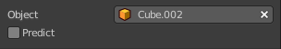
Goal Boid Rule
Seek the goal.

Object
Specifies the goal object. If not specified, Boid force fields with negative Strength are used as goals.

Predict
Predict target’s movements.

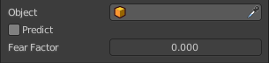
Avoid Boid Rule
Avoid “predators”.

Object
Specifies the object to avoid. If not specified, Boid force fields with positive Strength are used as predators.

Predict
Predict target’s movements.

Fear Factor
Avoid object if danger from it is above this threshold.


Avoid Collision Boid Rule
Avoid objects with activated Deflection.

Boids
Avoid collision with other boids.

Deflectors
Avoid collision with deflector objects.

Look Ahead
Time to look ahead in seconds.

Separate Boid Rule
Boids move away from each other.

Flock Boid Rule
Copy movements of neighboring boids, but avoid each other.

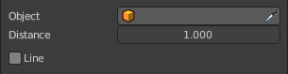
Follow Leader Boid Rule
Follows a leader object instead of a boid.

Object
Pick the leader object.

Distance
Distance behind leader to follow.

Line
Follow the leader in a line.


Queue Size
How many boids that are allowed to follow in a line.


Average Speed Boid Rule
Maintain average velocity.

Speed
Percentage of maximum speed.

Wander
How fast velocity’s direction is randomized.

Level
How much velocity’s Z component is kept constant.


Fight Boid Rule
Move toward nearby boids.

Fight Distance
Attack boids at a maximum of this distance.

Flee Distance
Flee to this distance.

Remove Boid Rule
Remove the boid rule from the list.

Move Up / Move Down Boid Rule
Move the boid rule up or down the list.

Physics Panel - Physics type Fluid

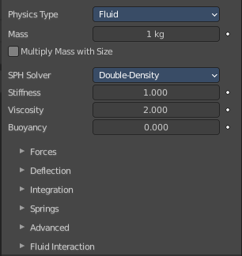
Fluid particles are similar to Newtonian particles. But the particles are influenced by internal forces like pressure, surface tension, viscosity, springs, etc. The range goes from liquids to slime, goo to sand and wispy.

Mass
Specify the mass of the particles.

Multiply Mass with Size
Causes larger particles to have larger masses.

SPH Solver
Smoothed-particle hydrodynamics (SPH) is a computational method used for simulating fluid flows. It is a mesh-free Lagrangian method where the coordinates move with the fluid.

Double density
An artistic solver with strong surface tension effects. Reveals the Spring sub panel.

Classic
A more physically accurate solver.

Stiffness
How incompressible the fluid is.

Viscosity
Linear viscosity. Use lower viscosity for thicker fluids.

Buoyancy
Artificial buoyancy force in negative gravity direction based on pressure differences inside the fluid.

Forces subpanel

Brownian
Specify the amount of Brownian motion. Brownian motion adds random motion to the particles based on a Brownian noise field.

Drag
A force that reduces particle velocity in relation to its speed and size (useful in order to simulate air drag or water drag).

Damp
Reduces particle velocity (deceleration, friction, dampening).

Deflection subpanel

Size Deflect
Use the particle size in deflections.

Die on Hit
Kill particle when it hits a deflector object.

Collision Collection
If set, particles collide with objects from the collection.

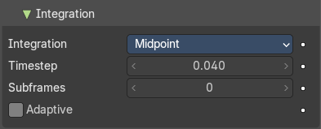
Integration subpanel
Integrators are a set of mathematical methods available to calculate the movement of particles. The following guidelines will help to choose a proper integrator, according to the behavior aimed at by the animator.

Integration

Euler
Also known as “Forward Euler”. Simplest integrator. Very fast but also with less exact results. If no dampening is used, particles get more and more energy over time. For example, bouncing particles will bounce higher and higher each time. Should not be confused with “Backward Euler” (not implemented) which has the opposite feature, the energy decrease over time, even with no dampening. Use this integrator for short simulations or simulations with a lot of dampening where speedy calculations are more important than accuracy.

Verlet
Very fast and stable integrator, energy is conserved over time with very little numerical dissipation.

Midpoint
Also known as “2nd order Runge-Kutta”. Slower than Euler but much more stable. If the acceleration is constant (no drag for example), it is energy conservative. It should be noted that in example of the bouncing particles, the particles might bounce higher than they started once in a while, but this is not a trend. This integrator is a generally good integrator for use in most cases.

RK4
Short for “4th order Runge-Kutta”. Similar to Midpoint but slower and in most cases more accurate. It is energy conservative even if the acceleration is not constant. Only needed in complex simulations where Midpoint is found not to be accurate enough.

Time step
The amount of simulation time (in seconds) that passes during each frame.

Sub frames
The number of simulation steps per frame. Sub frames to simulate for improved stability and finer granularity in simulations. Use higher values for faster-moving particles.

Adaptive
Automatically set the number of subframes.

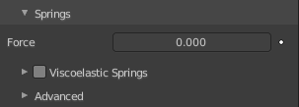
Springs Subpanel

Force
Spring force.

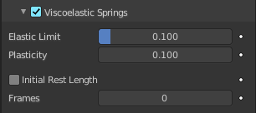
Viscoelastic Springs
Use viscoelastic springs instead of Hooke’s springs.

Elastic Limit
How much the spring has to be stretched/compressed in order to change its rest length.

Plasticity
How much the spring rest length can change after the elastic limit is crossed.

Initial Rest Length
Use initial length as spring rest length instead of 2 × particle size.

Frames
Create springs for this number of frames since particle’s birth (0 is always).

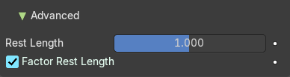
Advanced

Rest Length
Rest length of springs. Factor of particle radius. Checkbox sets this to be a factor of 2 × particle size.

Factor Rest Length
Spring rest length is a factor of 2* particle size.

Fluid Interaction
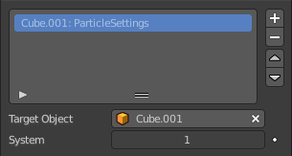
Add a particle system to interact with the fluid.

Particle Targets list
A list of the available particle systems.

Search Field
You can expand a search field at the bottom of the list. Type in your term and hit enter to filter for your term.

Invert
Exclude the search term instead of searching for it.

Sort by Name
Sort the List by name.

Target Object
Choose the target object that contains the particle system.

System
The index of the particle system on the target object.

